create database file;

use file;

create table e(

emp_id int,

emp_name varchar(100),

dept_id int);

create table d(

dept_id int,

dept_name varchar(100));

create table p(

project_id int,

emp_id int,

project_name varchar(100));

insert into e(emp_id,emp_name,dept_id)

values

(1,"Alice",10),

(2,"bob",20),

(3,"Charlie",30),

(4,"David",10),

(5,"Eve",40);

insert into d(dept_id,dept_name)

values

(10,"Hr"),

(20,"Finance"),

(30,"It"),

(40,"Admin"),

(50,"Marketing");

insert into p(project_id,emp_id,project_name)

values

(101,1,"alpha"),

(102,2,"beta"),

(103,3,"gamma"),

(104,4,"delta");

select * from e;

select * from d;

select * from p;

/*Write a query to get Employee and Department details using join.*/

select *

from e

inner join d

on e.dept_id=d.dept_id;

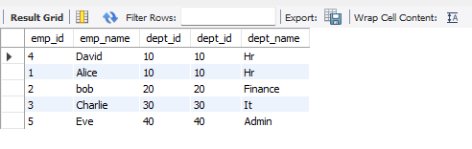

/*Write a query to retrieve all employees with their departments, even if the department is missing.*/

select emp_name,dept_name

from e

inner join d

on e.dept_id=d.dept_id;

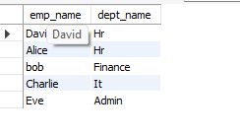

/*Write a query to get department details even if there are no employees in that department.*/

select emp_name,dept_name

from e

right join d

on e.dept_id=d.dept_id;

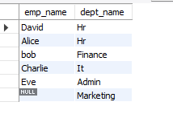

/*Write a query to get all employees and departments, whether matched or not. */

select emp_name,dept_name

from e

inner join d

on e.dept_id=d.dept_id;

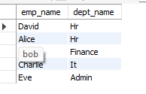

/*JOIN three tables (Employees, Departments, Projects) to get employee, department, and project information.*/

select *

from e

inner join d

on e.dept_id=d.dept_id

join p

on p.emp_id=e.emp_id;

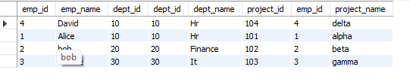

/*Find departments with no employees using a RIGHT JOIN.*/

select emp_name ,dept_name

from e

right join d

on e.dept_id=d.dept_id

where emp_name is null;



/*Write a query to get Employee and Department details using join with aliases.*/

select emp_id,emp_name,dept_name

from e

inner join d

on e.dept_id=d.dept_id;

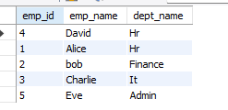

/*Write a query to find employees in the same department as other employees.*/

select e1.emp_name

from e e1

join e e2

on e1.dept_id = e2.dept_id

where e1.emp_name != e2.emp_name;

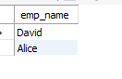

/*Write a query to find projects managed by employees in the 'IT' department.*/

select emp_name , dept_name , project_name

from d d

right join e e

on d.dept_id = e.dept_id

right join p p

on e.emp_id = p.emp_id where dept_name = "It" ;

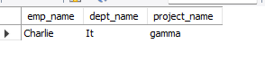

/*Write a query to show employees and their project information (even if not assigned to a project).*/

select emp_name , project_id , project_name

from e

left join p

on e.emp_id= p.emp_id ;

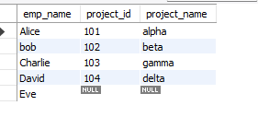

/*Find employees who work in departments with names starting with 'A'.*/

select emp_name , dept_name

from e

left join d

on e.dept_id = d.dept_id

where emp_name LIKE "A%";



/*Find the total number of employees in each department using GROUP BY and JOIN. */

select dept_name, count( emp_name)

from e

right join d

on e.dept_id = d.dept_id

group by dept_name;

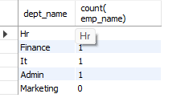

/*Get the list of departments with more than one employee. */

select dept_name , count(emp_name) as "no. of employees "

from e

right join d

on e.dept_id = d.dept_id

group by dept_name having count(emp_name)>1;